Difference between R-square and Adjusted R-Square

**R-squared or R2 explains the degree to which your input variables explain the variation of your output / predicted variable. So, if R-square is 0.8, it means 80% of the variation in the output variable is explained by the input variables. So, in simple terms, higher the R squared, the more variation is explained by your input variables and hence better is your model.**

**However, the problem with R-squared is that it will either stay the same or increase with addition of more variables, even if they do not have any relationship with the output variables. This is where “Adjusted R square” comes to help. Adjusted R-square penalizes you for adding variables which do not improve your existing model.**

**Hence, if you are building Linear regression on multiple variable, it is always suggested that you use Adjusted R-squared to judge goodness of model. In case you only have one input variable, R-square and Adjusted R squared would be exactly same.**

**Typically, the more non-significant variables you add into the model, the gap in R-squared and Adjusted R-squared increases.**

**Where we use R-square and Adjusted R-Square:**

In Regression problems.

**How R^2and adjusted-R^2 changes with addition of new independent features?**

R^2 formulae is as shown below:

**Sum of squared residuals also called the sum of squared Errors is SSE and Sum of squared Regression is SSR**

**Y = individual data points,**

**Yreg = predicted Regression points**

**Ymean = Average of Individual data points**

**SSE = Y - Yreg**

**SSR = Yreg - Ymean**

**so,**

**SST = SSE + SSR**

**= Y - Ymean**

* Residual is difference between actual value and predicted value

**The difference between the observed value of the dependent variable (y) and the predicted value (ŷ) is called the residual (e). Each data point has one residual. Residual = Observed value - Predicted value. e = y - ŷ Both the sum and the mean of the residuals are equal to zero.**

**Instead of finding the best fit line when we find the average output, average line becomes my best fit line**



**Important note:* We get value of R2 in between 0 to 1. the more nearer the value to 1 the line is a best fit.**

**R^2 value can also be below zero when our best fit line is worser than then average best fit line. SS(Res) > SS(total) then (SS(Res) / SS(total)) > 1**

**1 – (any value >1 is) a negative value.**

**Conclusion: model is not best fit**

* **R2 is used to check the goodness of best fit line**

**Our Linear equation is :**

As we keep on adding the independent variables our R^2 value increases

**Why the R^2 increases when we add more and more variables?**

**When we add more variables, linear regression algorithm will try to assign the new coefficients value (to newly added variable) so that SSres value decreases. In below example if X3 is new variable variable added then B3 is assigned in such a way that overall SSres value decreases.**

**If SSres is decreased then value of (SSres/SStot) Also decreases**

**1 - small value will make R2 to increase**

When we keep adding variables then R2 will always always increases, it will never decreased.

**Important point: Even we add another independent feature, there is possibility that this newly added feature does not have any correlation with output target variable. even though we are adding it and our R2 value increases.**

**But R2 is not differentiating anything for newly added feature and its keeps on increasing the value which gives us insights that we need a way by which we can reduce the effect of non-correlated features in our model**

**We then calculate adjusted-R^2:**

**========================**

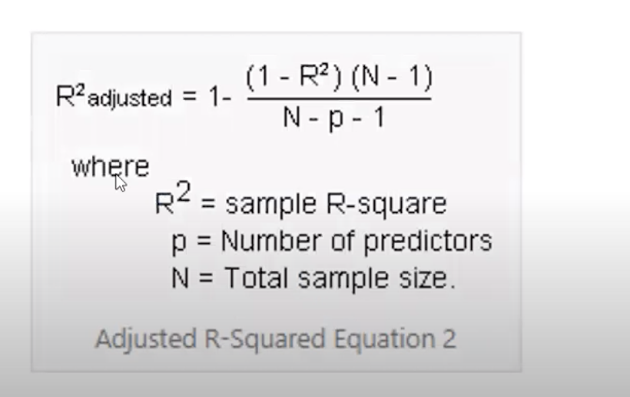

**Now as we increase the number of features (increasing p value), then (N-p-1) will become small number**

**then ((1-R^2)(N-1)/N-p-1) becomes the larger number**

**and then we subtract 1 - above bigger value —> R^2-adj decreases**

**Please note:* The R^2-adj will only decrease when the newly added feature is not correlated to output**

**If this newly added feature is correlated with output then our R^2 value will be increased,**

**then (1-R^2) will become a smaller value**

**anything multiplied with smaller number will be a smaller number —> ((1-R^2)(N-1)/N-p-1) becomes the smaller number**

**and hence R2-adj will increase**

